**Wholeness Emerging Bodywork Intake Form**

*CONFIDENTIAL INFORMATION*

Today’s Date

Name Date of Birth

Address

City State Zip

Phone (home) (work/cell) email

Occupation

Emergency contact name & number

Referred by:

Are you currently in pain or experiencing any discomfort? If so, please briefly explain and indicate those areas below

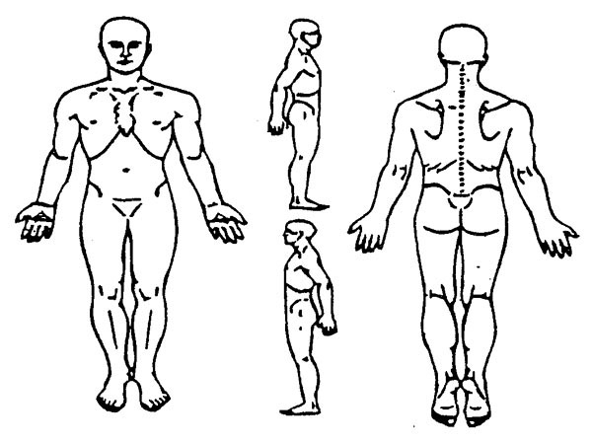

Describe any chronic pain/tension

What makes it better?

What makes it worse?

Are you currently under the care of a physician, chiropractor or alternative medicine practitioner? If yes, what are you being treated for?

Please list any medications (prescription or non-prescription), vitamins and supplements you are currently taking:

Have you had any injuries or surgeries in the past that may influence today’s treatment?

_________________________________________________________________________________

***Intake Form – Page 2 of 2***

Please check all the areas of the body that you give permission to be massaged:

[ ]All [ ]Back [ ]Legs [ ]Buttocks [ ]Arms [ ]Abdomen [ ]Chest [ ]Neck [ ]Head [ ]Face [ ]Feet

What do you hope to accomplish with this massage? (i.e. relaxation, decrease back pain, increase flexibility, etc.)

What is your daily intake of: Water: Caffeine: Alcohol:

Please check any of the following that apply to you in the past or present:

|  |  |  |  |  |  |
| --- | --- | --- | --- | --- | --- |
| **Condition/Complaint** | **Past** | **Present** | **Condition/Complaint** | **Past** | **Present** |
| **Headaches**  **Type:** |  |  | **Pins and Needles in arms, legs,**  **Hands or feet** |  |  |
| **Heart Problems** |  |  | **Neurological problems** |  |  |
| **Pacemaker** |  |  | **Spinal Problems** |  |  |
| **Blood Clots/DVT\*** |  |  | **Herniated/Bulging Discs** |  |  |
| **High/Low BP** |  |  | **Osteoarthritis** |  |  |
| **Infections** |  |  | **Arthritis** |  |  |
| **Contagious Diseases** |  |  | **Anxiety** |  |  |
| **Pitted Edema** |  |  | **Depression/Panic** |  |  |
| **Cancer: Surgery, Radiation or Chemo (specify below)\*** |  |  | **Sleep Disturbance** |  |  |
| **If yes to cancer: Did your treatment include removal, radiation or testing of any lymph nodes? (specify below)\*** |  |  | **Loss of Memory** |  |  |
| **Lymph Edema\*** |  |  | **Whiplash** |  |  |
| **Allergies (specify bellow)** |  |  | **Bruise Easily** |  |  |
| **Varicose Veins** |  |  | **Constipation/Diarrhea** |  |  |
| **Skin Conditions** |  |  | **Contact Lenses** |  |  |
| **Painful/Swollen Joints** |  |  | **Dentures/Partials** |  |  |
| **Sinus Conditions** |  |  | **Loss of smell/taste** |  |  |
| **Asthma** |  |  | **Artificial/Missing limbs** |  |  |
| **Diabetes** |  |  | **Auto-immune disorder** |  |  |
| **Epilepsy or Seizures** |  |  | **Sciatica** |  |  |
| **Fainting Spells** |  |  | **Cold Hands/feet** |  |  |

*Further explanation of any condition or other information:* ___________________________________________________

*The following sometimes occurs during massage; they are normal responses to relaxation. Trust your body to express what it needs:*

* *Need to move or change positions*
* *Sighing, yawning, change in breath*
* *Stomach gurgling*
* *Emotional feelings and/or expressions*
* *Energy shifts*
* *Falling asleep*
* *Memories*

Client (or legal guardian) Signature___________________________________________________Date_________________________________

**Wholeness Emerging Bodywork**

**Policy & Procedures**

**Health Intake:**

* You will be asked to complete a health intake form before your first visit and update it every 12 months.
* It is the responsibility of the client to keep the Massage/Bodywork Practitioner informed of any current medical conditions and/or any changes in health.
* Each session is completely confidential, except as required by law.

**Cancellations/No Shows:**

* Please give 24 hours notice when cancelling appointments.  Missed appointments without 24 hrs notice will be charged the full session fee.
* Cancellation fees are the responsibility of the client and must be paid in full before the next visit.

**Payments and Session Times:**

* Payment is due in full at time of service by cash, check, or credit card.
* Fees are subject to change. Notice will be given.
* Sessions are offered at 60, 90 and 120 minutes.

**Health and Well Being:**

* If you have any cold, flu or COVID-19 like symptoms (fever, fatigue, dry cough, aches/pain, runny nose, shore throat, shortness of breath and/or gastrointestinal issues), stomach virus, poison ivy, skin rash or anything contagious – please reschedule your appointment.
* Please remove any jewelry prior to session beginning.
* All clients will be properly draped at all times. A full sheet sized towel is used to cover the body except the area being worked on.
* Some clients may experience muscle soreness the next day. This should not last more than two days.

__________________________________________ _______________________________________

Client (or legal guardian) Signature Date

**Wholeness Emerging Bodywork Massage Informed Consent**

I, ______________________________, (client or legal guardian) understand that Massage Therapy provided by, Mandy Froula, LMT, HTCP, of Wholeness Emerging Bodywork, is intended to enhance relaxation, reduce pain caused by muscle tension, increase range of motion, improve circulation and offer a positive experience of touch. Any other intended purposes for massage therapy are specified below:

____ I understand that Massage Therapy is not a substitute for medical treatment or medications, and that it is recommended that I concurrently work with my Primary Caregiver for any condition I may have. I am aware that the Massage Therapy Practitioner does not diagnose illness or disease, does not prescribe medications, and that spinal manipulations are not part of session.

____ I have informed the Massage Practitioner of all my known physical conditions, medical conditions and medications. I have consulted a Medical Doctor or Licensed Medical Health Care Practitioner regarding any checked or described condition. I understand that there shall be no liability on the practitioner’s part due to my forgetting to relay any pertinent information about my health or condition.

____ I realize it is my sole responsibility to keep the Massage Practitioner updated on any changes in my physical health. I understand that Mandy Froula, LMT, HTP, shall not be liable should I fail to do so.

____ I understand if at any point during the session I am uncomfortable or uneasy with the procedures being administered and/or if I experience pain, it is my responsibility to IMMEDIATELY inform the Massage Practitioner, so that the technique can be terminated or adjusted to a level of comfort.

____ Your signature below authorizes the release of all of your medical records on file in this office, for the

purpose of processing your claims, to the following: your attorney, the healthcare providers attending to said

condition, and the insurance case managers. Medical records will not be edited unless otherwise stated in

an exclusive release of medical records signed through your attorney.

____ Massage in the era of COVID-19: Be assured that Mandy Froula with Wholeness Emerging Bodywork, has always followed state and federal regulations and recommended universal personal protection and disinfection protocols to limit transmission of all diseases in her office and continues to do so. That said, I understand that, as with the transmission of any communicable disease like a cold or the flu, I may be exposed to COVID-19, also known as "Coronavirus", at any time or in any place. Despite Mandy’s careful attention to sterilization, disinfection, and use of personal barriers, there is still a chance that I could be exposed to an illness in her office, just as you might be at your gym, grocery store, or favorite restaurant. "Social Distancing" nationwide has reduced the transmission of the Coronavirus. Although Mandy has taken measures to provide social distancing in her practice (including the shared lobby space), due to the nature of the protocols provided, it is not possible to maintain social distancing between the client, practitioner and sometimes, like in the shared lobby space, other clients. Although exposure is unlikely, I accept the risk and consent to treatment.

____ I understand that all sessions are strictly non-sexual.

__________________________________________ _______________________________________

Client (or legal guardian) Signature Date